Video Link: https://www.youtube.com/watch?v=pwWIegHgNRw&t=70s
https://github.com/malvik01/Real-Time-Streaming-with-Azure-Databricks
https://spark.apache.org/docs/latest/api/python/reference/pyspark.ss/index.html
https://www.databricks.com/blog/feature-deep-dive-watermarking-apache-spark-structured-streaming
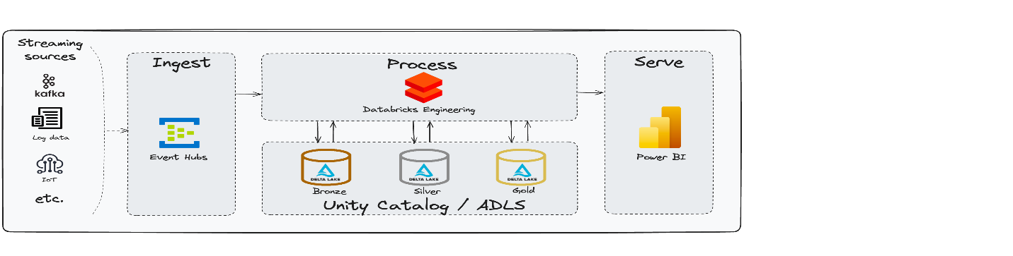

- Data Sources: Streaming data from IoT devices or social media feeds. (Simulated in Event Hubs)
- Ingestion: Azure Event Hubs for capturing real-time data.
- Processing: Azure Databricks for stream processing using Structured Streaming.
- Storage: Processed data stored Azure Data Lake (Delta Format).
- Visualization: Data visualized using Power BI.
Azure Services Required
- Databricks Workspace (Unity Catalog enabled)
- Azure Data Lake Storage (Premium)
- Azure Event Hub (Basic Tier)
Azure Databricks Configuration Required
- Single Node Compute Cluster: 12.2 LTS (includes Apache Spark 3.3.2, Scala 2.12)
- Maven Library installed on Compute Cluster: com.microsoft.azure:azure-eventhubs-spark_2.12:2.3.22
Importing the libraries.
--------------------------------------------------------------------------------------------------
from pyspark.sql.functions import *
from pyspark.sql.types import *
-----------------------------------------------------------------------------------------------------------
The code block below creates the catalog and schemas for our solution.
The approach utilises a multi-hop data storage architecture (medallion), consisting of bronze, silver, and gold schemas within a 'streaming' catalog.
------------------------------------------------------------------------------------------------------------------
try:
spark.sql("create catalog streaming;")
except:
print('check if catalog already exists')

try:
spark.sql("create schema streaming.bronze;")
except:
print('check if bronze schema already exists')

try:
spark.sql("create schema streaming.silver")
except:
print('check if silver schema already exists')

try:
spark.sql("create schema streaming.gold;")
except:
print('check if gold schema already exists')
-------------------------------------------------------------------------------------------------------------------------------
check if catalog already exists
check if bronze schema already exists
check if silver schema already exists
check if gold schema already exists
Bronze Layer
Set up Azure Event hubs connection string.
---------------------------------------------------------------------------------------------------------------------------------
# Config
# Replace with your Event Hub namespace, name, and key
connectionString = "Paste connection string here"
eventHubName = "Type event hub name here"

ehConf = {
'eventhubs.connectionString' : sc._jvm.org.apache.spark.eventhubs.EventHubsUtils.encrypt(connectionString),
'eventhubs.eventHubName': eventHubName
}
----------------------------------------------------------------------------------------------------------------------------------------
Reading and writing the stream to the bronze layer.
--------------------------------------------------------------------------------------------------------------------------------------------
# Reading stream: Load data from Azure Event Hub into DataFrame 'df' using the previously configured settings
df = spark.readStream \
.format("eventhubs") \
.options(**ehConf) \
.load() \

# Displaying stream: Show the incoming streaming data for visualization and debugging purposes
df.display()
# Writing stream: Persist the streaming data to a Delta table 'streaming.bronze.weather' in 'append' mode with checkpointing
df.writeStream\
.option("checkpointLocation", "/mnt/streaming/bronze/weather")\
.outputMode("append")\
.format("delta")\
.toTable("streaming.bronze.weather")
----------------------------------------------------------------------------------------------------------------------------------------
Silver Layer
Defining the schema for the JSON object.
-------------------------------------------------------------------------------------------------------------------------------
# Defining the schema for the JSON object
json_schema = StructType([
StructField("temperature", IntegerType()),
StructField("humidity", IntegerType()),
StructField("windSpeed", IntegerType()),
StructField("windDirection", StringType()),
StructField("precipitation", IntegerType()),
StructField("conditions", StringType())
])
----------------------------------------------------------------------------------------------------------------------------------
Reading, transforming and writing the stream from the bronze to the silver layer.
---------------------------------------------------------------------------------------------------------------------------------
# Reading and Transforming: Load streaming data from the 'streaming.bronze.weather' Delta table, cast 'body' to string, parse JSON, and select specific fields
df = spark.readStream\
.format("delta")\
.table("streaming.bronze.weather")\
.withColumn("body", col("body").cast("string"))\
.withColumn("body",from_json(col("body"), json_schema))\
.select("body.temperature", "body.humidity", "body.windSpeed", "body.windDirection", "body.precipitation", "body.conditions", col("enqueuedTime").alias('timestamp'))

# Displaying stream: Visualize the transformed data in the DataFrame for verification and analysis
df.display()

# Writing stream: Save the transformed data to the 'streaming.silver.weather' Delta table in 'append' mode with checkpointing for data reliability
df.writeStream\
.option("checkpointLocation", "/mnt/streaming/silver/weather")\
.outputMode("append")\
.format("delta")\
.toTable("streaming.silver.weather")
------------------------------------------------------------------------------------------------------------------------------------
Gold Layer
Reading, aggregating and writing the stream from the silver to the gold layer.
---------------------------------------------------------------------------------------------------------------------
# Aggregating Stream: Read from 'streaming.silver.weather', apply watermarking and windowing, and calculate average weather metrics
df = spark.readStream\
.format("delta")\
.table("streaming.silver.weather")\
.withWatermark("timestamp", "5 minutes") \
.groupBy(window("timestamp", "5 minutes")) \
.agg(avg("temperature").alias('temperature'), avg("humidity").alias('humidity'), avg("windSpeed").alias('windSpeed'), avg("precipitation").alias('precipitation'))\
.select('window.start', 'window.end', 'temperature', 'humidity', 'windSpeed', 'precipitation')

# Displaying Aggregated Stream: Visualize aggregated data for insights into weather trends
df.display()
# Writing Aggregated Stream: Store the aggregated data in 'streaming.gold.weather_aggregated' with checkpointing for data integrity
df.writeStream\
.option("checkpointLocation", "/mnt/streaming/weather_summary")\
.outputMode("append")\
.format("delta")\
.toTable("streaming.gold.weather_summary")

Another Example:
Scraping Weather prediction Data using Python and BS4
This article revolves around scraping weather prediction d data using python and bs4 library. Let’s checkout components used in the script –
BeautifulSoup– It is a powerful Python library for pulling out data from HTML/XML files. It creates a parse tree for parsed pages that can be used to extract data from HTML/XML files.
Requests – It is a Python HTTP library. It makes HTTP requests simpler. we just need to add the URL as an argument and the get() gets all the information from it.
We will be scraping data from https://weather.com/en-IN/weather/tenday/l/INKA0344:1:IN. Step 1 – Run the following command to get the stored content from the URL into the response object(file):
import requests
# to get data from website
file = requests.get("https://weather.com/en-IN/weather/tenday/l/INKA0344:1:IN")

Step 2 – Parse HTML content:
- Python3
# import Beautifulsoup for scraping the data
from bs4 import BeautifulSoup
soup = BeautifulSoup(file.content, "html.parser")

Step 3 – Scraping the data from weather site run the following code:
- Python3
# create empty list
list =[]
all = soup.find("div", {"class":"locations-title ten-day-page-title"}).find("h1").text

# find all table with class-"twc-table"
content = soup.find_all("table", {"class":"twc-table"})
for items in content:
for i in range(len(items.find_all("tr"))-1):
# create empty dictionary
dict = {}
try:
# assign value to given key

dict["day"]= items.find_all("span", {"class":"date-time"})[i].text
dict["date"]= items.find_all("span", {"class":"day-detail"})[i].text
dict["desc"]= items.find_all("td", {"class":"description"})[i].text
dict["temp"]= items.find_all("td", {"class":"temp"})[i].text
dict["precip"]= items.find_all("td", {"class":"precip"})[i].text
dict["wind"]= items.find_all("td", {"class":"wind"})[i].text
dict["humidity"]= items.find_all("td", {"class":"humidity"})[i].text
except:
# assign None values if no items are there with specified class

dict["day"]="None"
dict["date"]="None"
dict["desc"]="None"
dict["temp"]="None"
dict["precip"]="None"
dict["wind"]="None"
dict["humidity"]="None"

# append dictionary values to the list
list.append(dict)

find_all: It is used to pick up all the HTML elements of tag passed in as an argument and its descendants.
find:It will search for the elements of the tag passed.
list.append(dict): This will append all the data to the list of type list.
Step 4 – Convert the list file into CSV file to view the organized weather forecast data. Use the following code to convert the list into CSV file and store it into output.csv file:
import pandas as pd
convert = pd.DataFrame(list)
convert.to_csv("output.csv")

Syntax: pandas.DataFrame(data=None, index: Optional[Collection] = None, columns: Optional[Collection] = None, dtype: Union[str, numpy.dtype, ExtensionDtype, None] = None, copy: bool = False)
Parameters: data: Dict can contain Series, arrays, constants, or list-like objects.
index : It is used for resulting frame. Will default to RangeIndex if no indexing information part of input data and no index provided. columns: column labels to use for resulting frame. Will default to RangeIndex (0, 1, 2, …, n) if no column labels are provided.
dtype: It is used to set the Default value.
copy: It copy the data from input. default value is false.
read csv file using pandas
a = pd.read_csv("output.csv")
print(a)
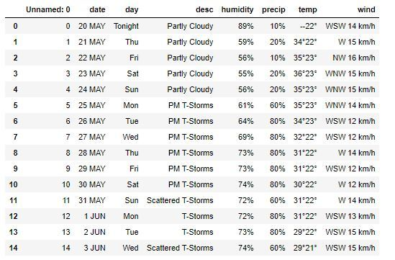
Output :

Looking to dive into the world of programming or sharpen your Python skills? Our Master Python: Complete Beginner to Advanced Course is your ultimate guide to becoming proficient in Python. This course covers everything you need to build a solid foundation from fundamental programming concepts to advanced techniques. With hands-on projects, real-world examples, and expert guidance, you'll gain the confidence to tackle complex coding challenges. Whether you're starting from scratch or aiming to enhance your skills, this course is the perfect fit. Enroll now and master Python, the language of the future!
………………………………………………………………………………………………………………………………………………………..

